**Creation of Relationship**

|  |  |
| --- | --- |
| Team Id | LTVIP2025TMID29041 |
| Project Name | Calculating family expenses |
| college | Kandula Lakshumma Memorial College of Engineering for Women |
| course | Computer Science  Engineering |

**Creation of relationships:**

**• Relationship Between Family Expenses and Daily Expenses Tables**

➢ Establish a logical link between each daily expense and the corresponding family member, allowing for better data organization, tracking, and reporting of expenses by individual or household.

* Go to All >> In the filter search for Relationships >> Open Relationships

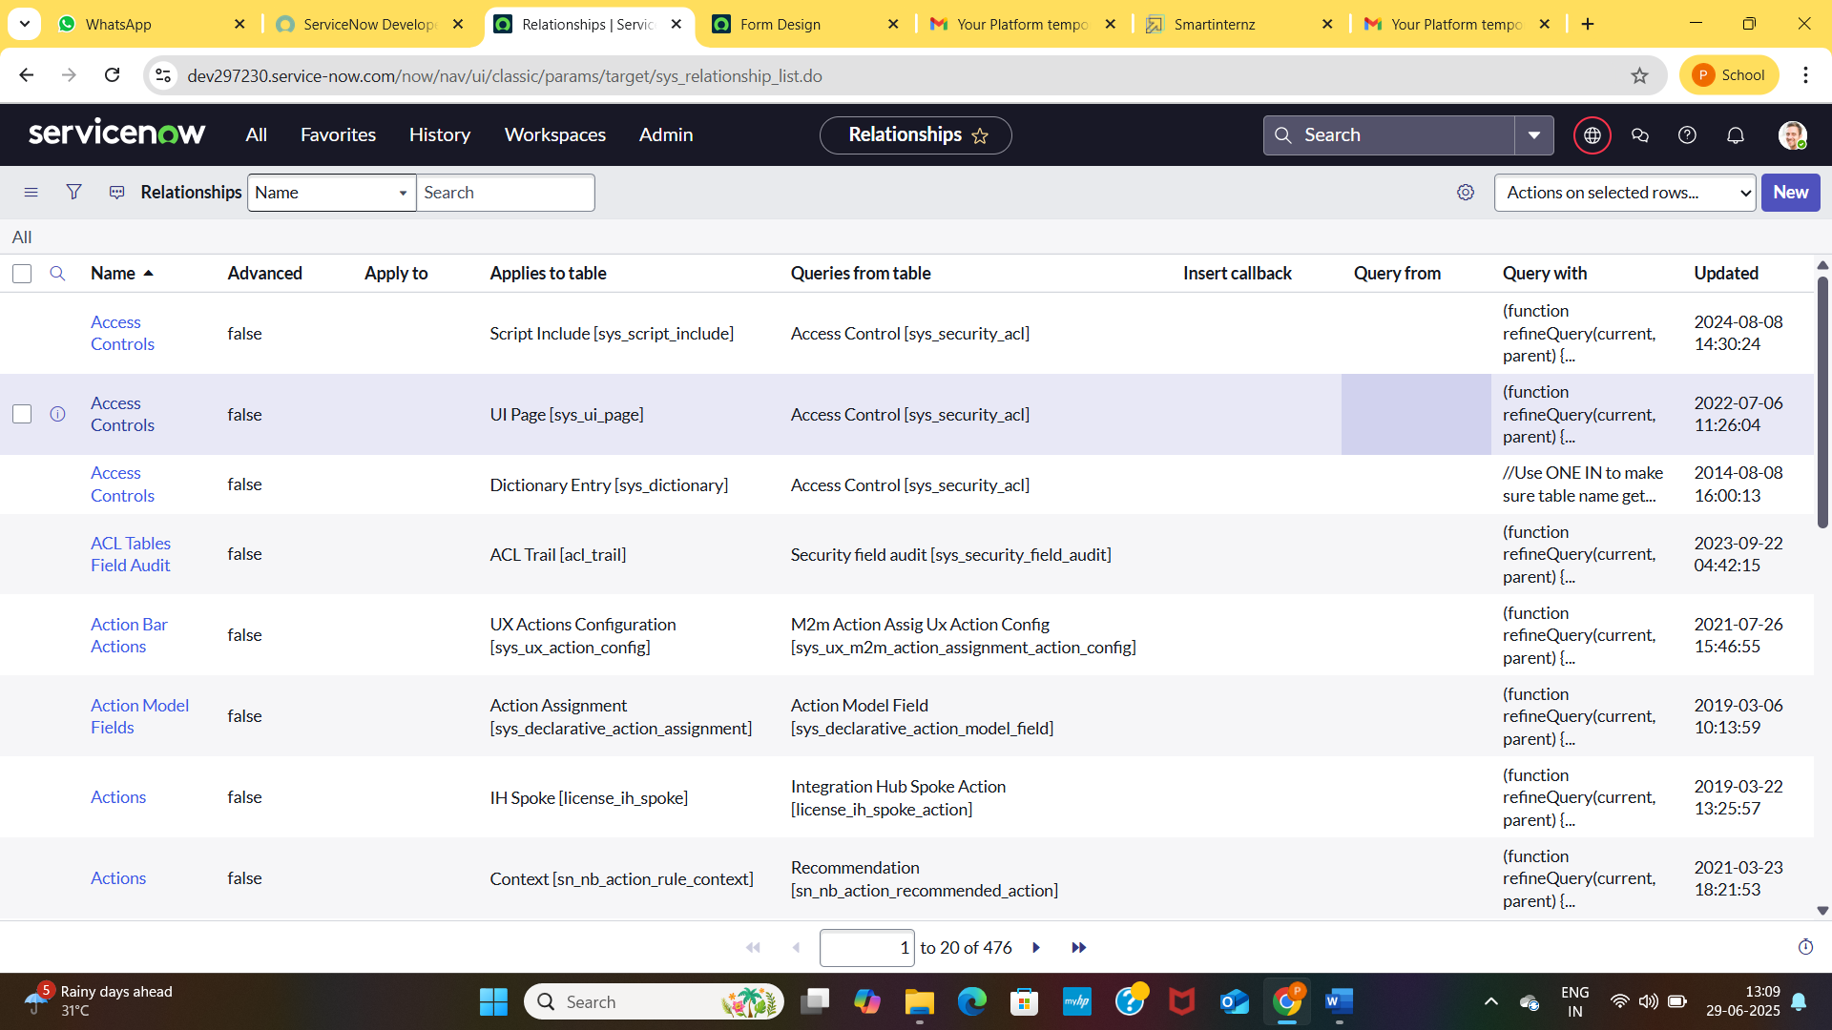

* Click on New.
* Enter the details:

Name : Daily Expenses

Applies to table : Select Family Expenses

Daily Expenses : Select Daily Expenses

* Click Save.

